OFFICE OF THE EXECUTIVE DIRECTOR
6 September 2026
Mr. Thapelo Nelson Maqalika
Director
African Solidarity Civic Organisation (ASCO)
RE: BOARD RESOLUTION APPOINTING YOU AS THE REGISTERED REPRESENTATIVE OF ASCO AT THE SOUTH AFRICAN REVENUE SERVICE (SARS)
Dear Mr. Maqalika,
I am pleased to formally communicate the resolution duly adopted by the Board of Directors of the African Solidarity Civic Organisation (ASCO) appointing you as the Registered Representative of the organisation for all matters relating to the South African Revenue Service (SARS).
This appointment takes effect immediately and authorises you to represent ASCO in all engagements with SARS, including the registration, administration, maintenance and management of the organisation’s tax affairs, eFiling profile, and all other statutory compliance matters.
The Board has expressed its full confidence in your integrity, competence and commitment to ensuring that ASCO maintains the highest standards of governance, transparency and regulatory compliance.
The Board further resolved that the Executive Director shall possess the same level of authority, rights and access as the Registered Representative in respect of all SARS matters. Accordingly, you are required to work in close collaboration with the Executive Director to ensure the effective administration of ASCO’s statutory obligations, while promoting accountability, institutional continuity and sound governance.
In fulfilling this responsibility, you are expected to:
•Act at all times in the best interests of ASCO.
•Safeguard the confidentiality of all organisational and SARS information.
•Keep the Board of Directors and the Executive Director informed of all material correspondence and engagements with SARS.
•Ensure that all statutory registrations, tax returns and compliance obligations are submitted accurately and within the prescribed timeframes.
•Cooperate fully with the Executive Director in carrying out the organisation’s governance and compliance responsibilities.
On behalf of the Board of Directors, I congratulate you on your appointment and wish you every success as you undertake this important responsibility in advancing the mission and good governance of ASCO.
Yours faithfully,
Mr. Bhekisisa Shandu
Executive Director
African Solidarity Civic Organisation (ASCO)
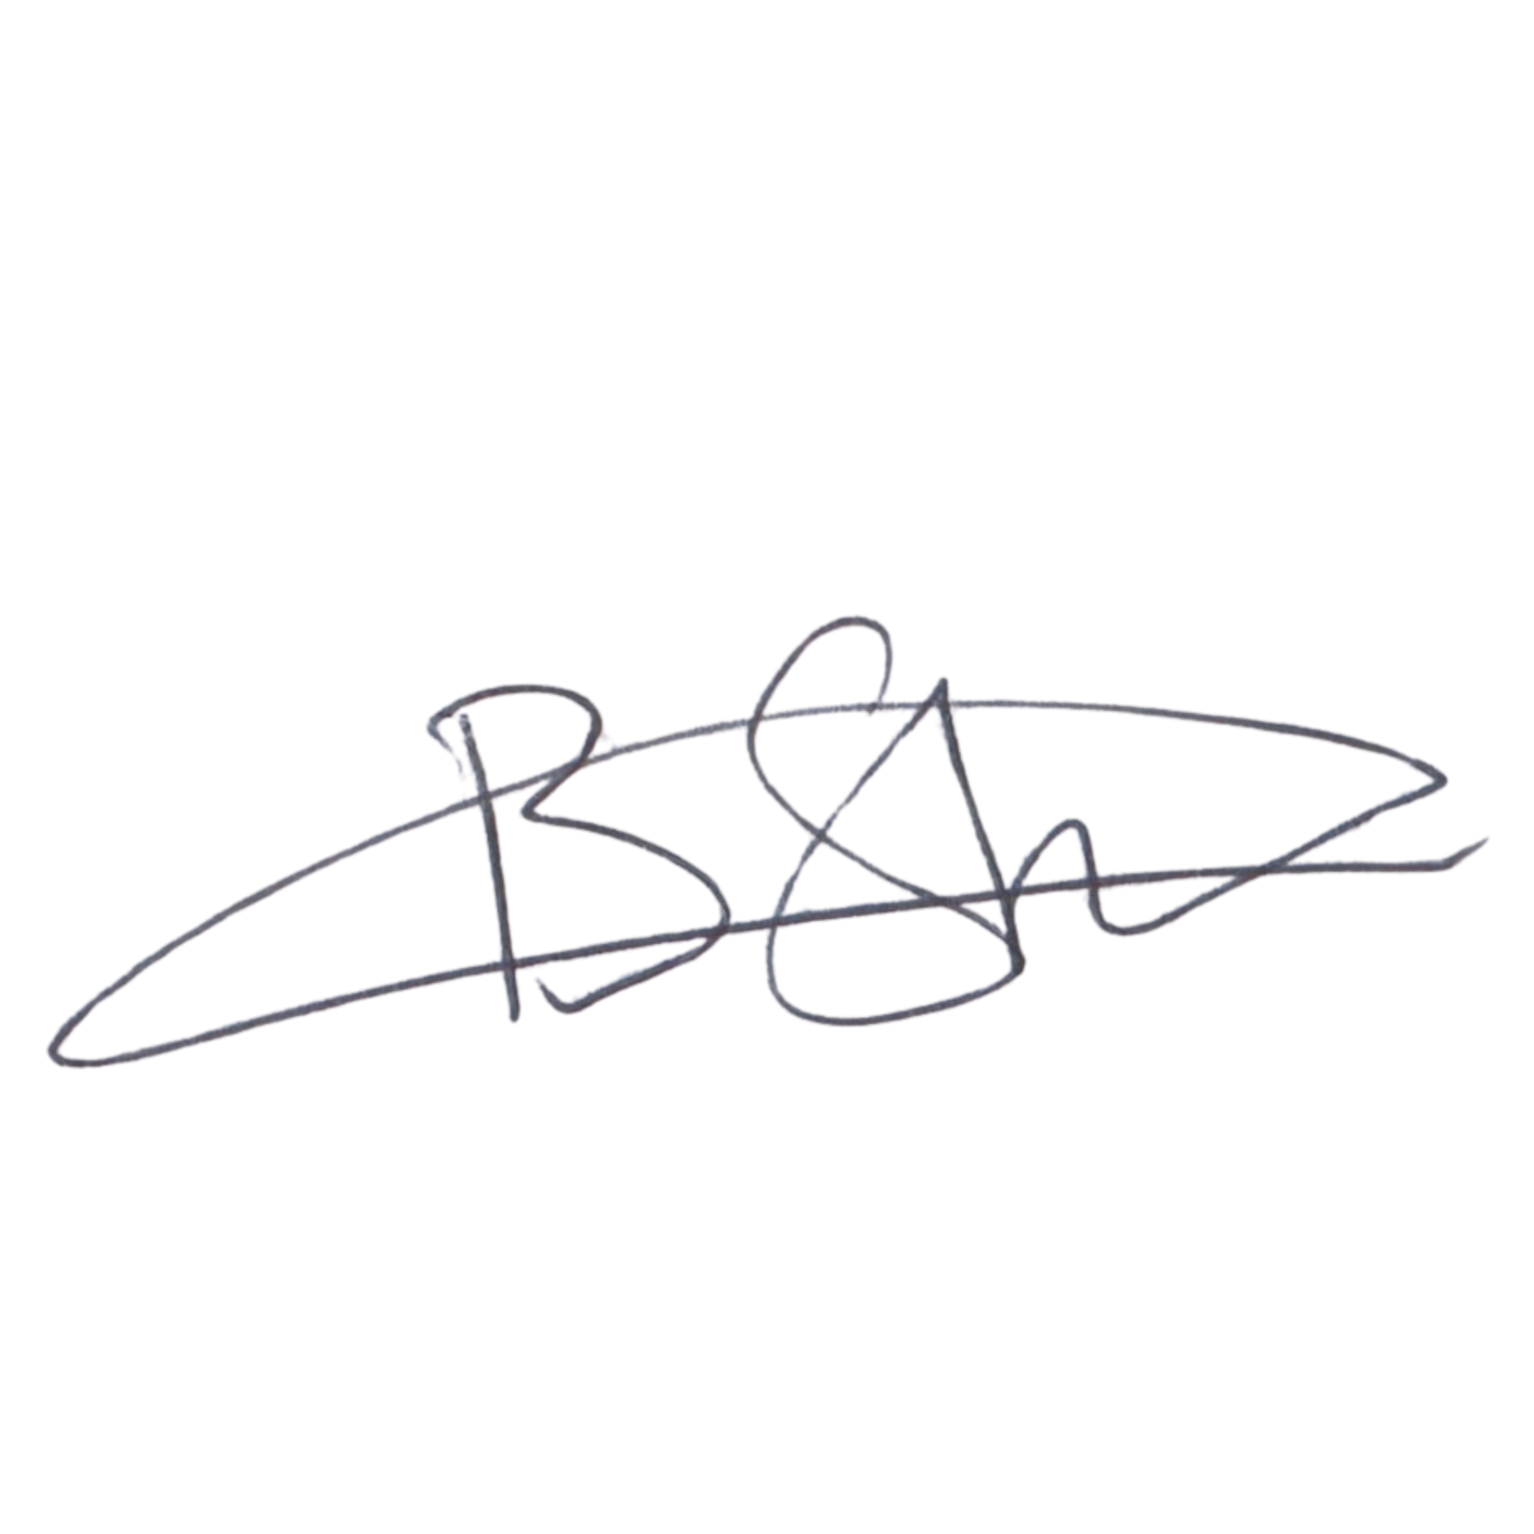
EXECUTIVE DIRECTOR
Mr. Bhekisisa Shandu
Signature:
____________________________
Date: 6 September 2026
____________________________
Issued under the authority of the Board of Directors.

